Vaibhav Shivaji Jadhav
Patan, Maharashtra · Leipzig, Germany · Vegetarian · Hindu- Parit

PERSONAL DETAILS

Date of Birth | 5th October 1994
Place of Birth | Pune, Maharashtra, India
Time of Birth | 2:56 PM
Zodiac Sign | Virgo (Kanya) · Gan: Dev
Height | 173 cm
Blood Group | B+
Religion / Caste | Hindu · Parit (Dhobi)
Diet | Vegetarian
Location | Leipzig, Germany (Permanent Resident)
EDUCATION & PROFESSION

Education | M.Eng. Mechatronics & Cyber-Physical Systems Technische Hochschule Deggendorf, Germany
 | B.Eng. Mechanical Engineering Savitribai Phule Pune University, Pune
Occupation | Senior Solution Engineer Deloitte Consulting Solutions GmbH, Germany
Experience | 5+ years · Industry 4.0 · International projects

FAMILY

I come from a close-knit, supportive family that balances cultural roots with a progressive outlook. We are a small family my parents in our hometown Patan, and my two brothers. Though the three of us are settled in different cities and countries, we remain deeply connected.

Father | Shivaji Laxman Jadhav · Retired Business Owner
Mother | Sangita Shivaji Jadhav · Homemaker
Elder Brother | Nagesh Shivaji Jadhav M.Eng. Germany · Area Manager, Silex Microsystems, Stockholm, Sweden
Younger Brother | Shambhuraj Shivaji Jadhav MBA · Regional Manager, Jio Petroleum, Amravati
WHAT I AM LOOKING FOR

I am not looking for a mirror image of myself. I am looking for a person with her own education, her own opinions, and her own way of seeing the world. Someone who has built something for herself — a career, a passion, a point of view and knows what she wants from life.

Germany is where my life is built. After eight years here, I am looking for someone open to building her future alongside me whether that means continuing her career, exploring new professional growth, or being brave enough to begin something new. I know what that journey feels like. I made it myself, and I will not let her make it alone.

Education preference: Engineering (Mechanical, CS, Mechatronics, E&TC, Electronics), MBBS, BDS, or a suitable bachelor's degree. Open to further studies or career in Germany.

"I know what it feels like to arrive in a new country alone, with a suitcase and a lot of hope.
I will not let her make that journey alone."

Contact: vaibhavj510@yahoo.in · +918625899953

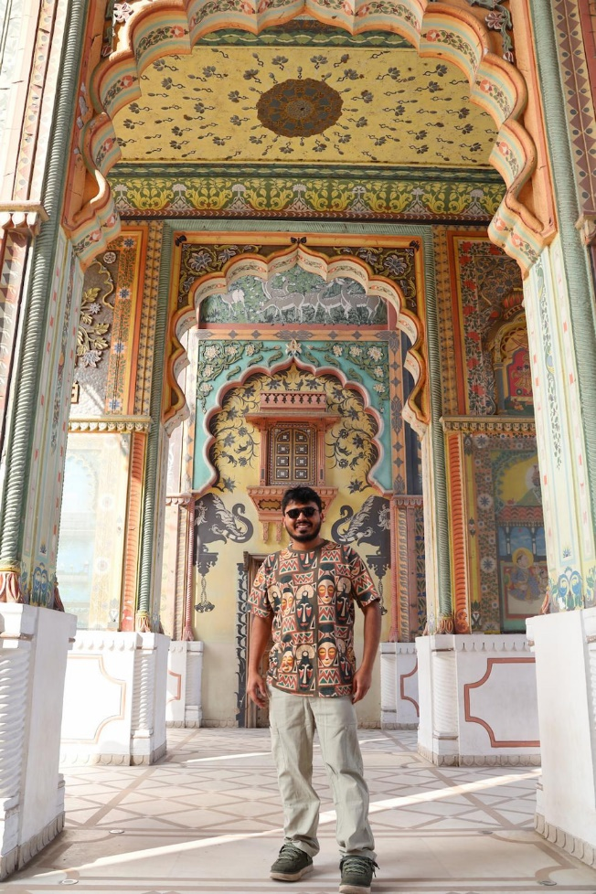

वैभव शिवाजी जाधव
Pune, महाराष्ट्र · Leipzig, जर्मनी · शाकाहारी · हिंदू-Parit (Dhobi)

वैयक्तिक माहिती

जन्मतारीख | ५ ऑक्टोबर १९९४
जन्मस्थान | पुणे, महाराष्ट्र, भारत
जन्मवेळ | दुपारी २:५६
राशी | कन्या · गण: देव
उंची | १७३ सेमी
रक्तगट | B+
धर्म / जात | हिंदू · परीट (धोबी)
आहार | शाकाहारी
भाषा | मराठी · हिंदी · इंग्रजी · जर्मन (B2)
सध्याचे ठिकाण | Leipzig, जर्मनी (कायमचे रहिवासी – PR)
शिक्षण व व्यवसाय

शिक्षण | M.Eng. Mechatronics & Cyber-Physical Systems Technische Hochschule Deggendorf, जर्मनी
 | B.Eng. Mechanical Engineering Savitribai Phule Pune University, पुणे
व्यवसाय | Senior Solution Engineer Deloitte Consulting Solutions GmbH, जर्मनी
अनुभव | ५+ वर्षे · Industry 4.0 · आंतरराष्ट्रीय प्रकल्प

कुटुंब

वडील | शिवाजी लक्ष्मण जाधव · निवृत्त व्यावसायिक
आई | संगीता शिवाजी जाधव · गृहिणी
मोठे बंधू | नागेश शिवाजी जाधव M.Eng. जर्मनी · Area Manager, Silex Microsystems, Stockholm, स्वीडन
धाकटे बंधू | शंभुराज शिवाजी जाधव MBA · Regional Manager, Jio Petroleum, अमरावती

शिक्षणाची अपेक्षा: अभियांत्रिकी (Mechanical, CS, Mechatronics, E&TC, Electronics), MBBS, BDS, किंवा योग्य पदवी. जर्मनीत काम किंवा उच्च शिक्षणास इच्छुक.

